# Source Control History

|  |  |
| --- | --- |
| Date | Evidence |
| 19/11/2020 (Thursday) | Ref 1 |
| 20/11/2020 (Friday) | Ref 2 |
| 23/11/2020 (Monday) | Ref 3 |
| 24/11/2020 (Tuesday) | Ref 4 |
| 25/11/2020 (Wednesday) | Ref 5 |

Ref 1

1. 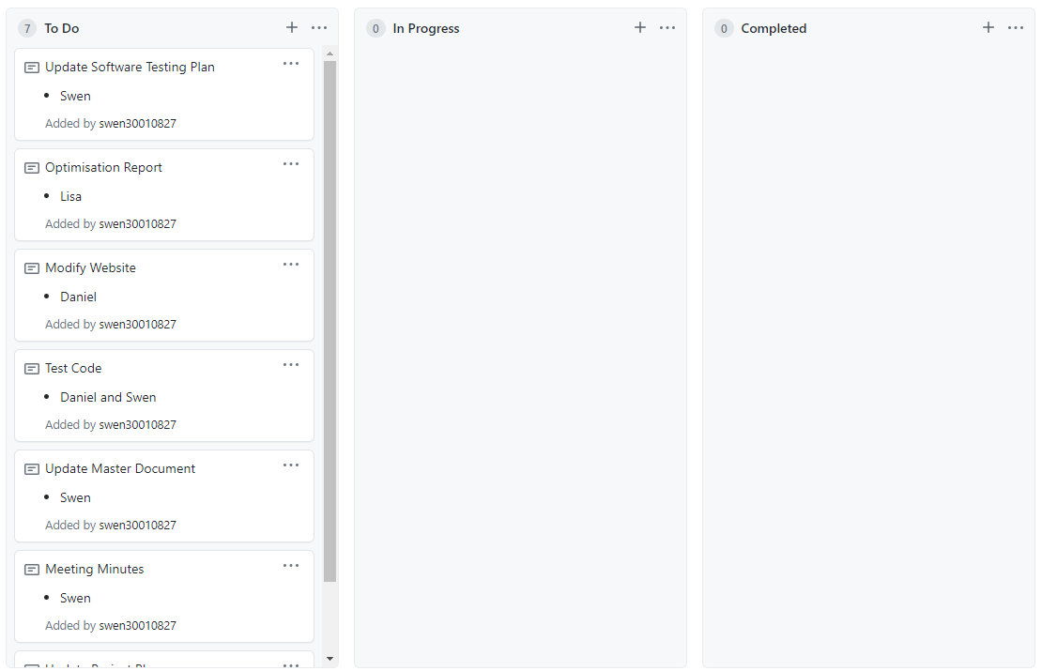
2. 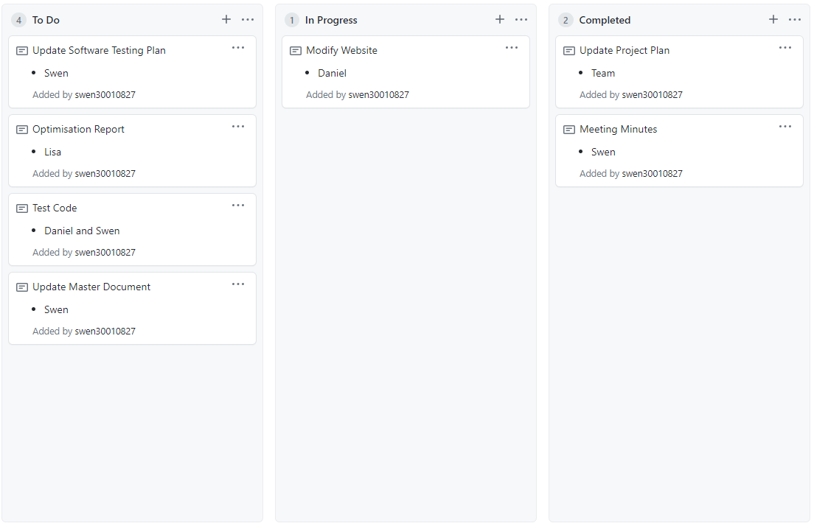

Ref 2

Ref 3

Ref 4

Ref 5